Sunday | Monday | Tuesday | Wednesday | Thursday | Friday | Saturday
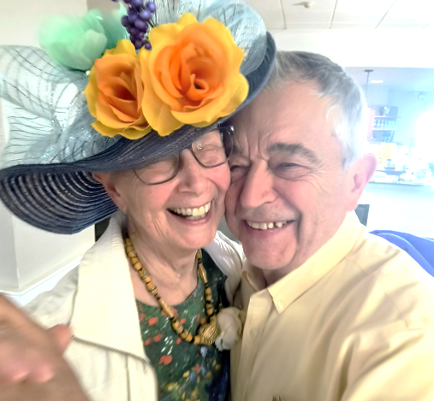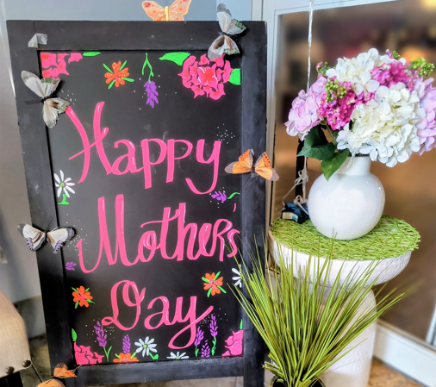  Vancouver Pointe  May 2026 Activities Calendar |  |  |  |  | 1  10:15 Level 2 (standing) Exercise (FR)  10:30 Relax and Chat Awhile (LR)  11:00 Level 1 (seated) Exercise (FR)  11:00 Seated Yoga with Jill (PNW)  1:30 Seated Volleyball (FR)  3:00 Old Time Gang (Meeting Room TBD)  7:00 Movie: The Prize Winner of Defiance, Ohio (TH) | 2  9-12:00 Mason’s Meeting (GP)  9 – 11:30 Team Wii Bowling (TH)  10:30 Relax and Chat Awhile  12:15 Billiards (GP)  12:30 Mahjong (LIB)  1:30 Meditation (TH)  2:00 Spring Tea Party (Session 1)*  3:00 Beanbag Baseball (PNW)  6:00 RummiKub (LIB)  7:00 Movie: Water for Elephants (TH)
3  1:30 Church (non-denominational) (PNW)  2:00 Spring Tea Party (Session 2)*  2:30 Mexican Train (GP)  3:00 Heartland TV Series (TH)  6:00 Bingo (PNW)  7:00 Movie: Ragtime (TH) | 4  10:00 Men’s Bible Study (TH)  10:15 Level 2 (Standing) Exercise (FR)  10:30 Relax and Chat Awhile (LR)  11:00 Level 1 (Seated) Exercise (FR)  12-1:30 Jewelry Sorting Volunteer Project (GP)  12:30-2:30 Smart Phone Assistance (BR) *  1:30 -3 Forum for Thought (TH)  3 – 4:30 Open Art Studio  3:00 Cribbage (GP), Shuffleboard (FR)  5:30 Hand and Foot (GP) )  6:00 Pinochle(GP) | 5  10:15 Tai Chi LIVE Fitness Class (FR)  10:30 – 11:30 Blood Pressure Screening (TH)  10:30 Relax and Chat Awhile (LR)  1:00 Drumming w/ Marie (PNW)  3:00 Beanbag Baseball (PNW)  3:00 Bridge (LR)  6:00 Pinochle (GP), Hand & Foot (HWGC) | 6  10:00 Wii Bowling Practice (teams/subs) (TH)  10:15 Level 2 (standing) Exercise w/Marti  10:30 Relax and Chat Awhile (LR)  11:00 Level 1 (seated) Exercise (FR)  1:00 Blackjack (GP)  3:00-4:00 Happy Hour  w/ James Clem (BR)  6:00 Double-Deck Pinochle (LR)  6:00 Single-Deck Pinochle (GP)  7:00 Action/Crime Series: Reacher (TH) | 7  9:30 Single Deck Pinochle (HWGC)  10:15 Tai Chi LIVE Fitness Class (FR)  10:30 Relax and Chat Awhile (LR)  11:00 Reflections (Share Stories) (LIB)  1:00 Chess Game Time (GP)  2:00 Beanbag Baseball:  Residents vs. Staff (BR)  4:00 Stitchery Witchery Group (GP)  5:30 Poker (Open to All Players) (HWGC)  6:00 RummiKub (LIB), Cribbage (LR) | 8  10:15 Level 2 (standing) Exercise (FR)  10:30 Relax and Chat Awhile (LR)  11:00 Level 1 (seated) Exercise (FR)  2:00 Andy’s Line Dancing Lessons (BR)  7:00 Movie: The Usual Suspects (R for severe profanity & violence (TH) | 9  9-12:00 Mason’s Meeting (GP)  9 – 11:30 Team Wii Bowling (TH)  10:30 Relax and Chat Awhile  12:15 Billiards (GP)  12:30 Mahjong (LIB)  1:30 Meditation (TH)  3:00 Beanbag Baseball (PNW)  6:00 RummiKub (LIB)  7:00 Movie: Mr. Mom (TH)
10 Mother’s Day  10 – 1:30 Mother’s Day Brunch Buffet  (last seating at 1pm)  1:30 Church (non-denominational) (PNW)  2:10 TRIP: SW WA Wind Symphony Concert *  2:30 Mexican Train (GP)  3:00 Heartland TV Series (TH)  6:00 Bingo (PNW)  7:00 Movie: Nonnas (TH) | 11  10 – 2 Quilt Group (PNW)  10:00 Men’s Bible Study (TH)  10:15 Level 2 (Standing) Exercise (FR)  10:30 Relax and Chat Awhile (LR)  11:00 Level 1 (Seated) Exercise (FR)  12 –1:30 Jewelry Sorting Volunteer Project(GP)  12:30-2:30 Smart Phone Assistance (BR) *  1:30-3 Forum for Thought (TH)  3:00 Open Art Studio  3:00 Cribbage (GP), Shuffleboard (FR)  5:30 Hand and Foot (GP)  6:00 Pinochle (GP) | 12  10:15 Tai Chi Fitness Class (FR)  10:30 – 11:30 Blood Pressure Screening(TH)  10:30 Relax  1:00 Drumming w/Marie (PNW)  2:00 Town Hall (BR)  3:00 Beanbag Baseball (PNW)  3:00 Bridge (LR)  6:00 Pinochle (GP) , Hand & Foot (HWGC) | 13  10:00 Wii Bowling Practice (teams/subs) (TH)  10:15 Level 2 (standing) Exercise w/Marti  10:30 Relax and Chat Awhile (LR)  11:00 Level 1 (seated) Exercise (FR)  1:00 Blackjack (GP)  1:00- 3:00 TRIP: Shopping at ReTails *  3:00 Happy Hour w/ Ken Brewer (BR)  6:00 Double-Deck Pinochle (LR)  6:00 Single-Deck Pinochle (GP)  7:00 Action/Crime Series: Reacher (TH) | 14 9:30 Single Deck Pinochle (HWGC)  10:00 Wing Leader Meeting (GP)  10:15 Tai Chi LIVE Fitness Class (FR)  10:30 Relax and Chat Awhile (LR)  1:00 Chess Game Time (GP)  3:00 Beanbag Baseball (PNW)  3:00 Presentation: 10 Warning Signs of Alzheimer’s Disease (TH)  4:00 Stitchery Witchery Group (GP)  5:30 Poker (Open to All Players) (HWGC)  6:00 Cribbage (LR), RummiKub (LIB) | 15  10:15 Level 2 (standing) Exercise (FR)  10:30 Relax and Chat Awhile (LR)  11:00 Level 1 (seated) Exercise (FR)  11:00 Seated Yoga with Jill (PNW)  1:30 Seated Volleyball (FT)  2:30 May Birthday Celebration and  The “Not So” Newly Wed Game (BR)  7:00 Movie: CODA (2021) (TH) | 16  9-12:00 Mason’s Meeting (GP)  9 – 11:30 Team Wii Bowling (TH)  10:30 Relax and Chat Awhile (LR)  11:00 TRIP: Water Resource Center and Lunch at Thai Little Home Restaurant*  12:15 Billiards (GP)  12:30 Mahjong (LIB)  1-3 Hatch Family Celebration for Harriett – All Are Invited for Cake and Coffee (BR)  1:30 Meditation (TH)  3:00 BBB postponed to 5/17/26 @ 3pm  4:00 Dinner & a Movie: War Horse (TH)*  6:00 RummiKub (LIB)  7:00 Movie: War Horse (repeat showing)
17  1:30 Church (non-denominational) (PNW)  2:30 Mexican Train (GP)  3:00 Beanbag Baseball make-up day (PNW)  3:00 Heartland TV Series (TH)  6:00 Bingo (PNW)  7:00 Movie: Secondhand Lion (TH)  24 1:30 Church (non-denominational) (PNW)  2:30 Mexican Train (GP)  3:00 Heartland TV Series (TH)  6:00 Bingo (PNW)  7:00 Movie: The Great Exotic Marigold Hotel (TH)  31  10:00 Heartland (earlier time) (TH)  2:30 Pre-concert Talk (TH)  3:00 Vancouver Symphony Orchestra Concert (Live-Stream)  7:00 Movie: The Second Best Exotic Marigold Hotel | 18  10:00 Men’s Bible Study (TH)  10:15 Level 2 (Standing) Exercise (FR)  10:30 Relax and Chat Awhile (LR)  11:00 Level 1 (Seated) Exercise (FR)  12-1:30 Jewelry Sorting Volunteer Project (GP)  12:30-2:30 Smart Phone Assistance (BR) *  1:30-3 Forum for Thought (TH)  3:00 Open Art Studio  3:00 Cribbage (GP), Shuffleboard (FR)  5:30 Hand and Foot (GP) 6:00 Pinochle (GP)  25  10:00 Men’s Bible Study (TH)  10:15 Level 2 (Standing) Exercise (FR)  10:30 Relax and Chat Awhile (LR)  11:00 Level 1 (Seated) Exercise (FR)  12-1:30 Jewelry Sorting Volunteer Project (GP)  12:30-2:30 Smart Phone Assistance (BR) *  1:00 Book Club (LIB)  1:30-3 Forum for Thought (TH)  2-3:00 Forum for Thought (TH)  3:00 Open Art Studio  3:00 Cribbage (GP), Shuffleboard (FR)  5:30 Hand and Foot (GP) 6:00 Pinochle (GP) | 19  10-3 Vendor: Linda’s Accessories (Lobby)  10:15 Tai Chi LIVE Fitness Class (FR)  10:30 – 11:30 Blood Pressure Screening (TH)  10:30 Relax and Chat Awhile (LR)  1:00 Drumming w/ Marie (PNW)  3:00 Beanbag Baseball (PNW)  3:00 Bridge (LR)  6:00 Pinochle (GP), Hand & Foot (HWGC)  26  10:15 Tai Chi LIVE Fitness Class (FR)  10:30 – 11:30 Blood Pressure Screening (TH)  10:30 Relax and Chat Awhile (LR)  1:00 Drumming w/ Marie (PNW)  3:00 Beanbag Baseball (PNW)  3:00 Bridge (LR)  6:00 Pinochle (GP), Hand & Foot (HWGC) | 20  10:00 Wii Bowling Practice (teams/subs) (TH)  10:15 Level 2 (standing) Exercise w/Marti  10:30 Relax and Chat Awhile (LR)  11:00 Level 1 (seated) Exercise (FR)  1:00 Blackjack (GP)  3:00 Happy Hour w/Ron Ruedi (BR)  6:00 Double-Deck Pinochle (LR)  6:00 Single-Deck Pinochle (GP)  7:00 Action/Crime Series: Reacher (TH)  27  10:00 Wii Bowling Practice (teams/subs) (TH)  10:15 Level 2 (standing) Exercise w/Marti  10:30 Relax and Chat Awhile (LR)  11:00 Level 1 (seated) Exercise (FR)  1:00 Blackjack (GP)  3:00 Country-Theme Happy Hour  w/Gary Moon (BR)  6:00 Double-Deck Pinochle (LR)  6:00 Single-Deck Pinochle (GP)  7:00 Action/Crime Series: Reacher (TH) | 21  9:30 Single Deck Pinochle (HWGC)  10:15 Tai Chi LIVE Fitness Class (FR)  10:30 Relax and Chat Awhile (LR)  11:00 Reflections (Share Stories) (LIB)  1:00 Chess Game Time (GP)  3:00 Beanbag Baseball (PNW)  4:00 Stitchery Witchery Group (GP)  4-6:30 Candlelight Dinner w/Music by King Louie and Renato  5:30 Poker (Open to All Players) (HWGC)  6:00 RummiKub (LIB), Cribbage LR)  28  9:30 Single Deck Pinochle (HWGC)  10:00 Sharing Support Group, for Residents Who Care for Others (TH)  10:15 Tai Chi LIVE Fitness Class (FR)  10:30 Relax and Chat Awhile (LR)  11:00 Reflections (Share Stories) (LIB)  1:00 Chess Game Time (GP)  2:00 Paint ‘n Sip: Summer Flower Field*  3:00 Beanbag Baseball (PNW)  4:00 Stitchery Witchery Group (GP)  5:30 Poker (Open to All Players) (HWGC)  6:00 RummiKub (LIB), Cribbage LR) | 22  10:15 Level 2 (standing) Exercise (FR)  10:30 Relax and Chat Awhile (LR)  10:30 Diners’ Forum (BR)  11:00 Level 1 (seated) Exercise (FR)  2:00 Andy’s Line Dancing Lessons (BR)  7:00 Movie: The 12th Man (TH)  29  10:15 Level 2 (standing) Exercise (FR)  10:30 Relax and Chat Awhile (LR)  11:00 Level 1 (seated) Exercise (FR)  7:00 Movie: The Color Purple (TH) | 23  9-12:00 Mason’s Meeting (GP)  9 – 11:30 Team Wii Bowling (TH)  10:30 Relax and Chat Awhile (LR)  12:15 Billiards (GP)  12:30 Mahjong (LIB)  12:30 Trip: Farmer’s Market *  1:30 Meditation (TH)  3:00 Beanbag Baseball (PNW)  6:00 RummiKub (LIB)  7:00 Movie: The Great Waldo Pepper (TH)  30  9-12:00 Mason’s Meeting (GP)  9 – 11:30 Team Wii Bowling (TH)  10:30 Relax and Chat Awhile (LR)  12:15 Billiards (GP)  12:30 Mahjong (LIB)  1:30 Meditation (TH)  3:00 Beanbag Baseball (PNW)  6:00 RummiKub (LIB)  7:00 Movie: North by Northwest (TH)
Key to Room Abbreviations: BR/ Bistro, DR/ Dining Room, FR/ Fitness Room, GP/ Game Parlor, HWGC/ Honor Wall Game Corner, LIB/ Library, LR/ Living Room, PNW/ Pacific NW Room, TH/ Theater …………………….……

